VAT No.: 606540595 QUOTATION DETAILS
Project: …Party Palace, Bharatpur Chitwan
Subject: Water Treatment Plant Quotation
Date: 04/10/2025
Dear Sir/Ma’am,
We are pleased to offer a high-quality water treatment solution tailored to meet the specific needs of
Party palace Bharatpur chitwan. Our system uses advanced filtration, reverse osmosis, and disinfection technologies to provide pure, safe water for your staff and clients.
We are confident that our solution will help ensure a reliable and efficient water supply for your operations, contributing to the success of your organization.
Thank you for considering Sky Way Water Solutions. We look forward to the opportunity to serve you.

With gratitude,
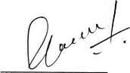

Baikuntha Rimal
Director, Sky Way Water Solution

VAT No.: 606540595

S.N. | DESCRIPTION OF  WORKS | UNIT | QUANTITY | RATE |  | AMOUNT | REMARKS
1.0 | WATER TREATMENT SYSTEM
i) | Pressure sand filter – 1000LPH vessel type should be FRP  internally polypropylene line size 21"x70"the vessel  single levered valve and the  media graded fine sand ,silex sand and pebbles. | Nos. | 1.00 | 10,5000.00 |  | 10,5000.00 | FRP Vessel
ii) | Multiport valve 40mm with flow meter | Nos. | 1.00 | 15,000.00 |  | 15,000.00 | Neo
iii) | Dosing System | Set | 1.00
 | Dosing pump flow - 6LPH  {With 100litr poly tank}  Make - E-Dose (NEO)  Tank Material - HDP | Set | 1 | 25,000.00 |  | 25,000.00 | E-dose Neo
iv) | Holding Tank 2000Ltr with | 1  1 |  | 25,000.00 |  | 25,000.00
v) | Inter connection pipe fittings | job |  | 35,000.00 |  | 35,000.00 | CPVC
vi) | Raw water pump 1HP | 1 |  | 15,500.00 |  | 15,500.00 | CGmini
With VAT TOTAL AMOUNT |  |  |  |  |  | 2,20,000.00

Instrumentation

- The filter plant has an automatic dosing system..
- Every 5 days the filter needs backwash.

Plumbing System
a. Valves, Pipelines, CPVC till the permeate line termination Point.
Term and Condition
- Delivery and Installation: The delivery and installation of the water treatment system will be completed within 15 days from the date of confirmation.
- Quotation Validity: This quotation is valid for a period of 3 weeks from the date of issuance.
- The warranty is for 2 years. for Vessel

Payment Mode:
- Advance Payment: A 50% advance payment is required at the time of order placement to initiate the procurement and installation process.
- Final Payment: The remaining 50% of the total amount should be settled upon completion of the installation job, ensuring satisfaction with the delivered solution before final payment.
These terms and conditions, coupled with our commitment to quality and reliability, aim to facilitate a smooth and mutually beneficial transaction process for all parties involved.

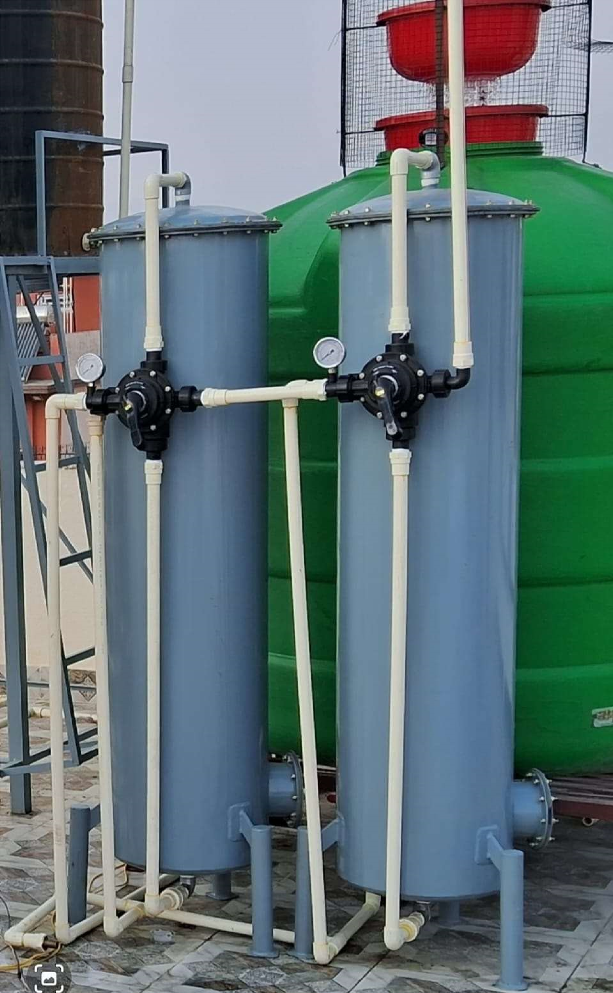

SKYWAY WATER SOLUTION PVT. LTD. Balaju-16, Kathmandu | Tel: 01-4986230 | Mob: 9851025058
Email: brimal37@gmail.com | Regd No.: 203049/075/076

